Web Programming Project Report

Done By: Madyan Omar U17200068

**What is my website about?**

In my website you will be able to find undefeated records and streaks performed by various athletes in both athletic sports and E-sports with a primary focus on Combat sports.

**Design aspect:**

Color format: 2 Main colors

Orange: #E8491D

Blue/Gray: #35424A

Font Families : 2 Fonts used

Default

Monospace

**Items used:**

41 Images, 10 Pages, 2 Videos, 1 Javascript page and 1 CSS.

**Structure of Website:**

Mixed Structure. Website is Fully responsive.

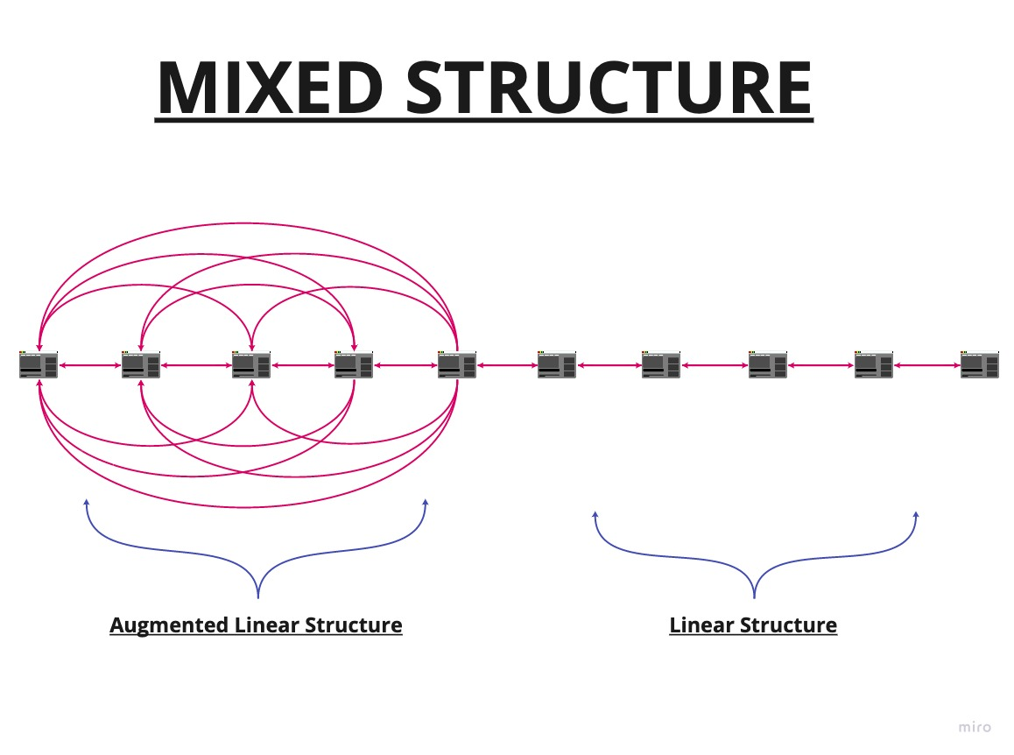

**Javascript:**

Uses function to keep count of days remaining before a fight.

**Additional Applications Used**

Photopea and Adobe Color Wheel.